

INGRAM MICRO PRODUCTS
SHIPPING GUIDE

GLOBAL RECEIVING REQUIREMENTS FOR ORDERS SHIPPING TO THE DISTRIBUTION CENTERS

TABLE OF CONTENTS

Page

Introduction 3
Wood pallet requirement 3 Wood packaging material (WPM) 3

Type and Quality of pallet 4

Pallet requirements 5

Examples of complaint pallets 6

Examples of non-compliant pallets 7 - 8

Proper pallet loading 9
Proper arrangement of models on pallet 9

Non-usable pallets 10

Packing slip requirements 10
Pallet labels 10.1

Master carton requirements 11

Sample of MRP label 12
Image of label and requirements 12

Contact information 13

Rating Label and Serial Number Logic 14

Master Carton Sample Art 15

Introduction

Ingram Micro Products has global shipping requirements for inbound shipments to the various Countries we ship too. In the following pages we have outline the guidelines that must be followed for proper receiving into our distribution centers.

Wood Pallet Requirement

One of the requirements is that all shipments must arrive on wood pallets - no floor loaded containers are accepted. Cartons are protected in transit by the pallet and shrink warp. The following are the pallet specs and guidelines:

Wood packaging material (WPM)

Wood packaging material made of unprocessed raw wood is recognized as a pathway for the introduction and spread of pests. To limit the entry and spread of quarantine pest through international trade, the International Plant Protection Convention adopted the International Standards for Phytosanitary Measures Guidelines for Regulating Wood Packaging Material in International Trade (ISPM 15).

Pallets must meet the conditions of ISPM 15 which mandates that all wood packaging material be appropriately treated and marked.

The ISPM 15 mark is required on at least two opposite sides (preferably both 48” sides) of pallets. If on only one side of the pallet, this is also acceptable.
Example of an ISPM 15 mark for a pallet.
Note: country code (US)will vary due to the country that is fumigating the pallet
The mark enables easy verification that wood meets necessary requirements during inspection at point of export or import

Type and Quality of a pallet
Product MUST be delivered on good wood, GMA Grade A or B, reusable block pallets, measuring 1016 X 1219 mm. Four way pallets are only allowed.
Type of block pallet
- Medium-density hardwood species Class 1, 3, or 21
(as defined by the NWPCA's Uniform Standard for Wood
Pallets). Good, sound material, free of knots larger than
one-third the board width. No knots above or adjacent
to stringer notches.
- Board dimensions must be as cited on page three below.
Stringers must be intact - no cracks, splits, or missing portions.
- All decking must be intact - no portions cracked, broken,
or missing.
- Repaired pallets must comply with all specifications, use
no metal repair plates, use no companion stringers,
and otherwise be engineered, manufactured, and repaired
in accordance with the NWPCA Uniform Standard for
Multiple Use Wood Pallets.
- No fasteners can be missing or protruding

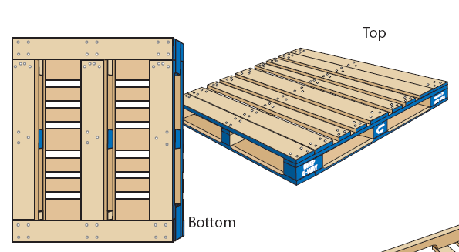
Example of a good GMA wood pallet.

Pallet requirements

- The maximum height of any pallet cannot compromise the individual carton integrity, and shall not exceed 2.00 meters.
- Lower than 2.00 meters is acceptable. Double stacking is acceptable.
- Four Way entry pallets only.
- Cartons must be delivered right side up and cubed on a pallet with no overhang and no hollow center.
- There must be a consistent number of units per carton throughout the life of the product
- There must be a consistent number of cartons per pallet throughout the life of the product
- All palletized cartons must have labels facing out.
- Each pallet must contain two address labels, one on each opposite side of the pallet with reference numbers.
- All palletized shipments must be stretch-wrapped or banded, with stretch wrap tied into the base of the pallet.
- All pallets are to be loaded with opening facing out toward the back of the container. DO NOT side load.
- Corner boards must be used on palletized shipments

Examples of Compliant pallets:

Examples of Non-Compliant pallets

Proper Pallet Loading Pattern
The diagram below the cartons would be damaged due to overhang. We would be required to rearrange the cartons onto separate pallets to eliminate the overhang.
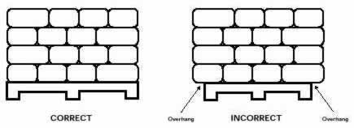
Pallet must be 1016 x 1219mm with fork access on both sides of the pallet.
Pallet height must not exceed 2.00 meter = 1016x1219.x 2000 mm

Proper Arrangement of SKUs (models) on a Pallet
In order to ease the receiving process, Ingram Micro requires that Purchase Orders, and models within those Purchase Orders, be grouped together as much as possible. However, consolidating purchase orders and mixed models onto a single pallet is acceptable for small orders provided that all products are clearly labeled and visible. The following diagram on the next page is an example of mixing models in one pallet.
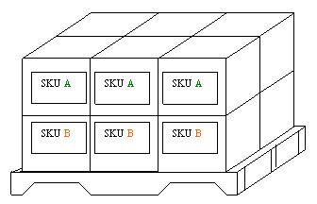
Ensure that models are grouped together in one single pallet if mixing models. Carton labels or print must face out from the pallet that would identify the model name or sku number. If carton quantities are different between models, the lower layers must contain the model with the higher quantity cartons and the top layers the model with the lowest number of cartons.
Non-usable pallets
Pallets are considered non-usable if they exhibit the following damage or defects:
- A board is missing, is skewed or is broken across
- More than two boards on base or edges or one cross board are/is splintered in such a way that more than one nail or screw shaft is visible
- One base bearing is missing, broken or splintered in such a way that more than one nail or screw shaft is visible
- Inappropriate materials have been used for pallet repair (boards or bearing bases too narrow or too short)
- The general condition of the pallet is so poor that its loading capacity is no longer adequate or loads could be damaged or soiled as a result.

Packing Slip requirements
A packing slip is required to move with the shipment. If multiple pallets are shipping, apply one packing slip to the last pallet on the container. It should be visible when opening container doors. Packing list should show all relevant shipment information for the total shipment
Required information for each packing slip:
- One packing list per purchase order or per shipment.
- Purchase order number
- Container number (if known)
- Shipper reference number
- Backorder status
- Pieces and weight
Required Information for Each Line Item
- Product description
- Ingram Micro Private Label part number and sku number if possible
- Number of units/eaches
- Number of cartons
- Pallet numbers
Full containers
- A separate packing slip is required for each purchase order for each container.
- If the shipment requires more than one container (e.g. multiple containers, one PO), a separate packing slip outlining the particulars of each container is mandatory. It should be visible when opening container doors. Packing list should show all relevant shipment information per each container.
Less than containers
- One packing list must be applied to the pallet or one of the pallets if multiple.

Pallet Label

Each pallet must contain two pallet labels, one on each opposite side of the pallet. No required size of pallet labels however the printing must be in large print and legible.
Labels must contain:
- PO number
- Shipper reference numbers
- Number of pallets - ex: 1 of 5, 2 of 5 etc
- PO numbers and reference numbers will be provided to you at the time the PO is placed

Master carton requirements
Each master carton must meet the following requirements:

Main panel
  - PO number
  - Reference number

Side Panel
  - Model no.
  - Quantity
  - Net Weight
  - Gross weight
  - EAN /UPC Code
  - Country of Origin: Made in XXXX
  - Serial # - Start # and End # (only if applicable)

See Example at end of document or online here

MRP (merchandise retail price) label – country of India

Required on the packaging of the units, a MRP label (Merchandise Retail Price) will need to be applied for all orders shipping to India.
An image of an MRP label and the required information is below. Some information will change based on when the order is placed.
Importers Name and Address | Ingram Micro India Limited
Importers Name and Address | 5th floor, Block-B, Godrej IT Park
Importers Name and Address | 2 Godrej Business District,
Importers Name and Address | Pirojshanagar, Vikhroli (W)
Importers Name and Address | Mumbai- 400 079
Generic Name | USB Optical Mouse
Month and Year of Import | MUST BE THE MONTH AND YEAR OF IMPORT
Quantity | 1 N
MRP (incl. of all taxes) | Rs. _____ RETAIL PRICE WILL BE PROVIDED AT TIME ORDER IS PLACE
In case of Consumer complaints | Manager Customer Service
Contact | Ingram Micro India Ltd.
 | Rajlaxmi Logistics Park, MH No. 311,
 | Village-Vadape, Nr.Shangrilla Resort
 | Bhiwandi Nasik By-Pass Road, Thane, Maharashtra-421302
Telephone: | Telephone : +02522-336417
Email ID: | Email: service@ingrammicro.co.in
VPN | YOUR MODEL NUMBER ENTERED HERE
NOTE: The month and year of import will change based on when the shipment will arrive in India. Please confirm before applying that the month is the month that the shipment will import into the Country.
The MRP cost will also be provided at the time of the order.
An image of the MRP label will need to be pre-approved before the shipment can be released to the forwarder. Failure to comply with the conditions above will result as a rework of peeling off the labels and applying the correct labels.

Please take time to review this guide thoroughly. Failure to not comply may result in penalty fines, subject to discretion.
If you have any question, please contact the Ingram Micro Products Senior Manager of Operations:
Amit Khajanchi | amit.khajanchi@ingrammicro.com

